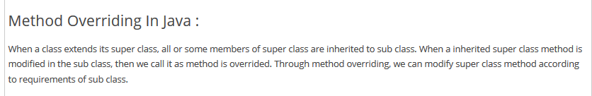

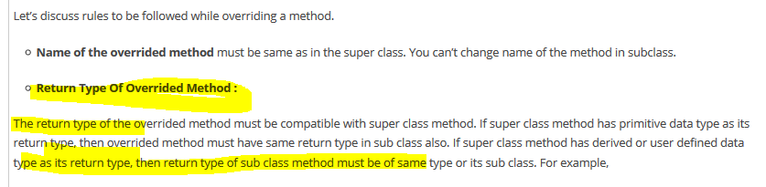



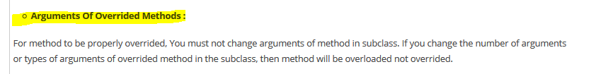

Difference between overriding and overloading

1. Method return type does not matter in overloading as compiler checks the method signature as return type can be same or different .Whereas return type matters in overriding as this must be same.
2. Overloading involves in same class but overriding involves in multiple classes
3. Arguments must be same in overriding but not in overloading
4. Overloading in static binding (compile type binding) whereas overriding is dynamic binding.
5. Visibility of overridden method cannot be decreased whereas this is not case with overloading methods.





